
Regional Economic Models, Inc.
Economic Impact of
Enacting a Feebates Program in Rhode Island
Prepared for
U.S. Environmental Protection Agency
and the
State of Rhode Island
By
Regional Economic Models, Inc.
Using
REMI Policy Insight
Single-Region State Model of Rhode Island
December 31, 2004

TABLE OF CONTENTS
TABLE OF CONTENTS 2
Executive Summary 3
Major Findings 4
1 Methodology & Assumptions 6
1-1 REMI Policy Insight 6
1-2 Assumptions 9
1-3 Simulation inputs 9
Consumer Spending on Gasoline 9
Consumption Reallocation 9
Government Spending 9
Feebates Simulation Inputs 10
2 Results and Analysis 12
2-1 Output 15
2-2 Gross State Product 17
2-3 Employment 19
2-4 Population 21
2-5 Real Disposable Income 22
2-6 State Revenue 24
Appendix: Data Calculations for Inputs into REMI Policy Insight 26
About REMI 28

Executive Summary
The Environmental Protection Agency (EPA) contracted Regional Economic Models (REMI) to assess the economic impact of a feebates program in four states; Connecticut, Rhode Island, Massachusetts, and Maine. The focus of the program was to promote the purchase of more fuel-efficient cars by placing a fee (surcharge) on high fuel-consumption vehicles and a rebate on fuel-efficient cars.
The feebate program is intended to be self-sustaining; the monetary amount of rebates given to fuel-efficient vehicle purchasers would equal the amount of fees received from high fuel-consumption vehicle purchasers. Included in the feebates would be the cost for the four states to implement the program. Consequently, there will not be any government spending to stimulate the economy. All economic stimulation is assumed to be the result of a decrease in the demand for gasoline. As sales of fuel-efficient vehicles increase, the demand for gasoline decreases. An increase in consumer spending on other goods results from consumers having more money from purchasing less gasoline. This decrease in demand for gasoline will cause a loss in revenue for gasoline stations and consequently this analysis assumed all four states would lose the revenue from tax on gasoline. This is a simplifying assumption for simulation purposes only. In reality, state governments can offset the loss in revenue using a variety of measures such as increasing tax on gasoline. If the states enacted such measures, they could reduce the loss in state revenue.
REMI performed five separate geographic analyses on the economic impact on each individual state and the combined region. This analysis focuses solely on the economic impact of a feebates program on the State of Rhode Island over a 15-year time horizon from 2006 to 2020. To quantify the indirect and induced effects of the policies, REMI captured all direct effects of the policies, including:
- The increase on consumer spending on other goods
- A loss in revenue for gasoline stations
- A loss in tax revenue for the State of Rhode Island

In examining the economic impact for each geographic region, three different feebate designs were modeled. Each scenario corresponds to levels in a loss of demand for gasoline consumption due to the increase in fuel efficiency. Scenario A assumes that the feebate policy will reduce 2020 gasoline consumption by the difference in consumption between 1990 and 2003. Scenario B assumes that the feebate policy will reduce 2020 gasoline consumption by the difference in consumption between 90% of 1990 and 2003. Scenario C assumes that the feebate policy will reduce 2020 gasoline consumption to 90% of 1990 consumption. Please see ‘Feebate Simulation Inputs’ in Section 1-3 for greater detail, and Appendix for data calculations.
This analysis does not quantify other important benefits that would be captured by a feebate program, and the primary impetus for implementing the policy in the first place, including reductions in carbon emissions, a variety of other air pollutants, and decreased dependence on foreign oil.
REMI received data regarding projections of gasoline consumption changes, and total costs and benefits of the feebates program from Mezler Engineering Services and Harold Ward. Data for this analysis was also provided by Northeast States for Coordinated Air Use Management (NESCAUM).

Major Findings
Table 1 shows the cumulative economic growth in the State of Rhode Island due to the feebates program over a 14-year time period for all three scenarios.
- Economic Growth Due to Feebate Policies in Rhode Island (Cumulative 2006 – 2020)
 | Scenario A | Scenario B | Scenario C
Employment (Avg Annual Increase)* | 49 | 128 | 466
Total Output (Mil 96$) | 82 | 212 | 775
Total GSP (Mil 96$) | 42 | 111 | 403
Population | 189 | 488 | 1,781
Real Disp Inc (Mil 96$) | 36 | 93 | 341
State Revenues (Mil 96$) | -74 | -194 | -706
*Employment is the average annual increase from the baseline. Employment is not cumulative and is based on output growth.

All three feebates scenarios in Table 1 show a slightly positive effect on the Rhode Island economy. The three scenarios follow similar trends; growth in employment, output, gross state product, population, and real disposable income. All three scenarios also show a loss in the amount of revenues collected by the State of Rhode Island. The loss in state revenue is the direct result of a loss in gasoline-tax collections by Rhode Island. It is important to note that all economic results presented in the report are inclusive of each other. The loss in state revenues is already included in the total output and total gross state product of the economy. Despite Rhode Island’s loss in state revenues the total output of the economy still improves by $82 million for scenario A, $212 million for scenario B, and $775 million for scenario C. If Rhode Island’s state government were to offset the loss in state revenue via other measures then the total output of Rhode Island would increase, although not in parallel.
Scenario A estimates: 49 new jobs, output increases of $82 million, gross state product increases of $42 million, population increases of 189 people, and real disposable income increases of $36 million. The only negative effect on the economy is a loss in Rhode Island state revenues of $74 million due to the loss in revenue from gasoline taxes. Again, the loss in state revenues is already reflected in all other economic variables. Output increases by $82 million and GSP increase by $42 million despite the loss in state revenues of $74 million.
Scenario B estimates: 128 new jobs, output increases of $212 million, gross state product increases of $111 million, population increases of 488 people, and real disposable income increases of $93 million. The estimated loss in state revenue is $194 million due to a loss in gasoline taxes. The loss in state revenues is already reflected in all other economic variables. Output increases by $212 million and GSP increase by $111 million despite the loss in state revenues of $194 million.
Scenario C estimates: 466 new jobs, output increase of $775 million, gross state product increases of $403 million, population increases of 1,781 people, and real disposable income increases of $341 million. The estimated loss in state revenue is $706 million due to a loss in gasoline taxes. The loss in state revenues is already reflected in all other economic variables. Output increases by $775 million and GSP increase by $403 million despite the loss in state revenues of $705 million.
Tables 2 and 3 show the annual increase of two specific years: 2010 and 2020. These graphs are not an accumulation of preceding years, but instead show how much growth Rhode Island would experience that single year. Both years follow a similar trend; growth in employment, output, gross state product, population, and real disposable income; and a loss in state revenues
- Economic Growth Due to Feebate Policies in Rhode Island, 2010
 | Scenario A | Scenario B | Scenario C
Employment | 37 | 95 | 348
Total Output (Mil 96$) | 4.181 | 10.850 | 39.580
Total GSP (Mil 96$) | 2.174 | 5.688 | 20.720
Population | 46 | 119 | 434
Real Disp Inc (Mil 96$) | 1.446 | 3.757 | 13.690
State Revenues (Mil 96$) | -3.804 | -9.912 | -36.050

- Economic Growth Due to Feebate Policies in Rhode Island, 2020
 | Scenario A | Scenario B | Scenario C
Employment | 72 | 187 | 685
Total Output (Mil 96$) | 7.874 | 20.460 | 74.720
Total GSP (Mil 96$) | 4.089 | 10.620 | 38.760
Population | 189 | 488 | 1,781
Real Disp Inc (Mil 96$) | 4.356 | 11.160 | 40.990
State Revenues (Mil 96$) | -7.491 | -19.554 | -71.046

1 Methodology & Assumptions

1-1 REMI Policy Insight
REMI Policy Insight® is the leading regional economic-forecasting and policy-analysis model. For this study, REMI developed Policy Insight for the State of Rhode Island. REMI built this model using the REMI model building system, which consists of hundreds of programs developed over the last two decades. The system assembled the State of Rhode Island model using data from the Bureau of Economic Analysis, the Bureau of Labor Statistics, the Department of Energy, the Bureau of Census, and other public sources.
REMI Policy Insight is a structural model, meaning that it clearly includes cause-and-effect relationships. The model is based on two key underlying assumptions from mainstream economic theory: households maximize utility and producers maximize profits. Since these assumptions make sense to most people, lay people as well as trained economists can understand the model.
In the model, businesses produce goods to sell to other firms, consumers, investors, governments and purchasers outside the region. The output is produced using labor, capital, fuel, and intermediate inputs. The demand for labor, capital and fuel per unit of output depends on their relative costs, since an increase in the price of any one of these inputs leads to substitution away from that input to other inputs. The supply of labor in the model depends on the number of people in the population and the proportion of those people who participate in the labor force. Economic migration affects the population size. People will move into an area if the real after-tax wage rates or the likelihood of being employed increases in a region.
Supply and demand for labor in the model determines the wage rates. These wage rates, along with other prices and productivity, determine the cost of doing business for every industry in the model. An increase in costs would decrease the share of markets supplied by local firms. This market share combined with the demand described above determines the amount of local output. The model has many other feedbacks. For example, changes in wages and employment impact income and consumption, while economic expansion changes investment and population growth impacts government spending.
Figure 1-1 is a pictorial representation of REMI Policy Insight. The Output block shows a business that sells to all the sectors of final demand as well as to other industries. The Labor and Capital Demand block shows how labor and capital requirements depend both on output and their relative costs. The Demographic block includes Population and Labor Supply, contributing to demand and wage determination. Economic migrants in turn respond to wages and other labor market conditions. Supply and demand interact in the Wage, Price and Profit block. Production costs determine market shares. Output depends on market shares and the components of demand.
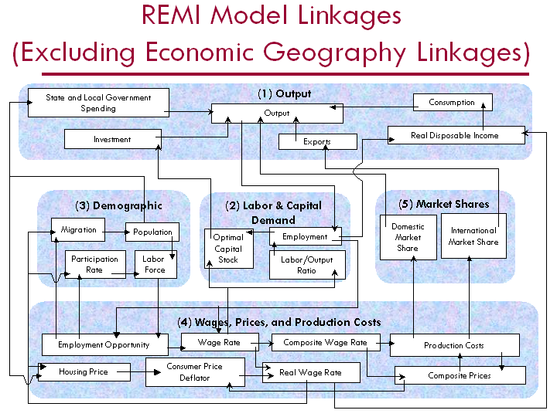
Figure 1-1 REMI Policy Insight overview
The REMI model brings together all of the above elements to determine the value of each of the variables in the model for each year in the baseline forecast as well as for simulation purposes. The model includes all the inter-industry interactions that are included in input-output models in the Output block, but goes well beyond an input-output model by including the linkages among all of the other blocks shown in Figure 1-1.
In order to broaden the model in this way, it is necessary to estimate key relationships. This is accomplished by using extensive data sets covering all areas in the country. These large data sets and two decades of research effort enable REMI to simultaneously maintain a theoretically sound model structure and build a model based on all the relevant data available.
The model has strong dynamic properties, which means that it forecasts not only what will happen but also when it will happen. This results in long-term predictions that have year-by-year change. This means that the long-term properties of general equilibrium models are preserved while maintaining accurate annual predictions and using estimates of key equations from primary data sources.
Figure 1-2 shows the policy simulation process for a scenario called Policy X. The effects of a scenario are determined by comparing the baseline REMI forecast with an alternative forecast that incorporates the assumptions for the scenario. The baseline REMI forecast uses recent data and thousands of equations to generate projected economic activity for a particular region. The policy variables in the model are set equal to their baseline value (typically zero for additive variables and one for multiplicative variables) when solving for the baseline forecast. To show the effects of a given scenario, these policy variables are given values that represent the direct effects of the scenario. The alternative forecast is generated using these policy variable inputs. Figure 1-2 shows how this process would work for a policy change called Policy X.
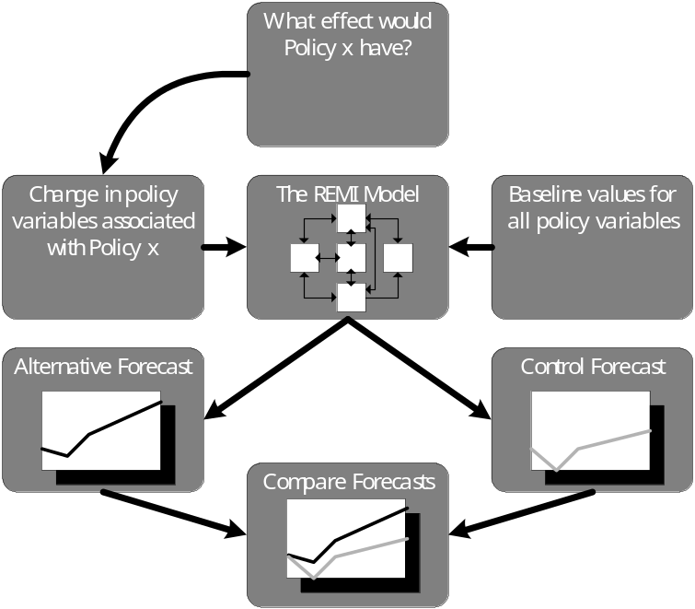
Figure 1-2 Policy X scenario

1-2 Assumptions
For this project, REMI examined the economic effects of feebate policies in the State of Rhode Island. REMI made the following simplifying assumptions:
- As fuel-efficient vehicles become more prevalent, there is a decrease in the amount of gas purchased.
- Any consumer spending saved due to buying less gasoline is reallocated onto other goods and services.
- All high fuel-consumption vehicles sold in Rhode Island are manufactured outside of Rhode Island. Consequently, any loss in motor vehicles sales will not reduce revenue for Rhode Island’s motor vehicle industry.
- The feebates program is self-sufficient; the fees collected for high fuel-consumption vehicles will equal the rebates given for fuel-efficient vehicles, plus the cost of program implementation.
- All growth in vehicle fleet size is constant
- There will not be any change in vehicle-miles-traveled or vehicle-hours-traveled due to a decrease in the cost of driving.
- All gasoline prices and tax rates are constant across the time-horizon.

1-3 Simulation inputs

Consumer Spending on Gasoline
As the ratio of fuel-efficient vehicles to high fuel-consumption vehicles increases, the total quantity of gasoline demanded by consumers decreases. REMI captured the decrease in demand by decreasing consumer spending for gasoline. Shown in ‘Consumer Spending on Gasoline’ on Tables 1-1, 1-2, 1-3.

Consumption Reallocation
Consumption reallocation transfers the money saved from purchasing less gas to purchasing other goods. The input is based on the assumption 2, all money saved from gas purchases will be spent on other goods. Shown in ‘Consumption Reallocation’ on Tables 1-1, 1-2, 1-3.

Government Spending
The feebates program is intended to be self-sufficient. There will not be any change in government spending due to the implementation of the program, feebate collection, or rebate distribution. However, there will be a loss in government spending due to a loss in state tax revenue on gas collections. The government-spending variable does assume the government will offset the loss in state tax revenue by decreasing the amount of government employees. Shown in ‘Government Spending’ on Tables 1-1, 1-2, 1-3. (See section 2-3)

Feebates Simulation Inputs
In examining the economic impact for each geographic region, three different feebate designs were modeled. Each scenario corresponds to levels in a loss of demand for gasoline consumption due to the increase in fuel efficiency. Scenario A assumes that the feebate policy will reduce 2020 gasoline consumption by the difference in consumption between 1990 and 2003. Scenario B assumes that the feebate policy will reduce 2020 gasoline consumption by the difference in consumption between 90% of 1990 and 2003. Scenario C assumes that the feebate policy will reduce 2020 gasoline consumption to 90% of 1990 consumption. The difference in gasoline consumption directly affects the simulation inputs for all three scenarios. Although each scenario has different target consumption rates, the annual growth rates are similar.
Scenario A estimates a decrease in consumption of gasoline by 23.512 million gallons in 2020 due to more fuel-efficient cars sold, a decrease from the baseline of 5%.
Table 1-1 Data Inputs for Scenario A (Mil 96$)
 | 2006 |  | 2007 |  | 2008 |  | 2009 |  | 2010 | 2011
Consumer Spending on Gasoline | -2.638 |  | -7.487 |  | -12.004 |  | -16.189 |  | -20.044 | -23.567
Consumption Reallocation | 2.638 |  | 7.487 |  | 12.004 |  | 16.189 |  | 20.044 | 23.567
Government Spending | -0.408 |  | -1.156 |  | -1.854 |  | -2.501 |  | -3.096 | -3.640
 | 2012 |  | 2013 |  | 2014 |  | 2015 |  | 2016 | 2017
Consumer Spending on Gasoline | -26.759 |  | -29.619 |  | -32.148 |  | -34.346 |  | -36.213 | -37.748
Consumption Reallocation | 26.759 |  | 29.619 |  | 32.148 |  | 34.346 |  | 36.213 | 37.748
Government Spending | -4.134 |  | -4.575 |  | -4.966 |  | -5.306 |  | -5.594 | -5.831
 | 2018 | 2019 |  | 2020 |  | Total
Consumer Spending on Gasoline | -38.952 | -39.825 |  | -40.403 |  | -397.943
Consumption Reallocation | 38.952 | 39.825 |  | 40.403 |  | 397.943
Government Spending | -6.017 | -6.152 |  | -6.241 |  | -61.472

Scenario B estimates a decrease in consumption of gasoline by 61.271 million gallons in 2020, a decrease in consumption from the baseline by 12%.
Table 1-2 Data Inputs for Scenario B (Mil 96$)
 | 2006 | 2007 |  | 2008 |  | 2009 |  | 2010 |  | 2011
Consumer Spending on Gasoline | -6.875 | -19.510 |  | -31.281 |  | -42.189 |  | -52.233 |  | -61.414
Consumption Reallocation | 6.875 | 19.510 |  | 31.281 |  | 42.189 |  | 52.233 |  | 61.414
Government Spending | -1.062 | -3.014 |  | -4.832 |  | -6.517 |  | -8.069 |  | -9.487
 | 2012 | 2013 |  | 2014 |  | 2015 |  | 2016 |  | 2017
Consumer Spending on Gasoline | -69.732 | -77.186 |  | -83.777 |  | -89.505 |  | -94.369 |  | -98.370
Consumption Reallocation | 69.732 | 77.186 |  | 83.777 |  | 89.505 |  | 94.369 |  | 98.370
Government Spending | -10.772 | -11.923 |  | -12.941 |  | -13.826 |  | -14.578 |  | -15.196
 | 2018 |  | 2019 |  | 2020 |  | Total
Consumer Spending on Gasoline | -101.508 |  | -103.782 |  | -105.287 |  | -1,037.017
Consumption Reallocation | 101.508 |  | 103.782 |  | 105.287 |  | 1,037.017
Government Spending | -15.680 |  | -16.032 |  | -16.264 |  | -160.192

Scenario C estimates a decrease in consumption of gasoline by 159.076 million gallons in 2020, a decrease in consumption from the baseline by 31%.
Table 1-3 Data Inputs for Scenario C (Mil 96$)
 | 2006 |  | 2007 |  | 2008 | 2009 | 2010 |  | 2011
Consumer Spending on Gasoline | -25.008 |  | -70.963 |  | -113.779 | -153.454 | -189.988 |  | -223.383
Consumption Reallocation | 25.008 |  | 70.963 |  | 113.779 | 153.454 | 189.988 |  | 223.383
Government Spending | -3.863 |  | -10.962 |  | -17.576 | -23.705 | -29.348 |  | -34.507
 | 2012 |  | 2013 |  | 2014 | 2015 | 2016 |  | 2017
Consumer Spending on Gasoline | -253.637 |  | -280.751 |  | -304.725 | -325.558 | -343.251 |  | -357.803
Consumption Reallocation | 253.637 |  | 280.751 |  | 304.725 | 325.558 | 343.251 |  | 357.803
Government Spending | -39.180 |  | -43.369 |  | -47.072 | -50.290 | -53.023 |  | -55.271
 | 2018 | 2019 |  | 2020 |  | Total
Consumer Spending on Gasoline | -369.216 | -377.488 |  | -382.964 |  | -3,771.967
Consumption Reallocation | 369.216 | 377.488 |  | 382.964 |  | 3,771.967
Government Spending | -57.034 | -58.312 |  | -59.158 |  | -582.672

2 Results and Analysis
Tables 2-1, 2-2, and 2-3 display the major economic effects for enacting a feebates program in Rhode Island, including changes in employment, output, gross state product (GSP), population, real disposable income, and state revenue collected. For a detailed explanation of all of the economic variables please see the corresponding section below. As shown in Tables 2-1, 2-2, and 2-3, enacting a feebates program in Rhode Island stimulates overall positive economic growth.
The majority of the growth in the Rhode Island economy is due to growth from consumption. As stated in Assumption 2 in section 1-2, money saved by consumer spending on gasoline will be reallocated to spending on other goods and services. As the sale of consumer goods increases, industries selling consumer goods increase output and hire more workers, who in turn can boost the economy by buying more goods. However, there are some negative impacts on the economy. The petroleum products industry and wholesale industry both experience losses due to decreased gasoline sales.
Table 2-1 Scenario A: Annual Growth Due to a Feebates Program
 | 2006 | 2007 |  | 2008 |  | 2009 |  | 2010 |  | 2011
Employment | 4 | 12 |  | 21 |  | 29 |  | 37 |  | 44
Total Output (Mil 96$) | 0.523 | 1.484 |  | 2.411 |  | 3.319 |  | 4.181 |  | 4.921
Total GSP (Mil 96$) | 0.279 | 0.774 |  | 1.274 |  | 1.740 |  | 2.174 |  | 2.571
Population | 3 | 9 |  | 19 |  | 32 |  | 46 |  | 61
Real Disp Inc (Mil 96$) | 0.137 | 0.427 |  | 0.748 |  | 1.076 |  | 1.446 |  | 1.820
State Revenues (Mil 96$) | -0.513 | -1.448 |  | -2.306 |  | -3.094 |  | -3.804 |  | -4.445
 | 2012 | 2013 |  | 2014 |  | 2015 |  | 2016 |  | 2017
Employment | 51 | 55 |  | 61 |  | 65 |  | 68 |  | 71
Total Output (Mil 96$) | 5.676 | 6.218 |  | 6.744 |  | 7.217 |  | 7.523 |  | 7.790
Total GSP (Mil 96$) | 2.953 | 3.227 |  | 3.517 |  | 3.742 |  | 3.906 |  | 4.047
Population | 78 | 94 |  | 110 |  | 126 |  | 141 |  | 155
Real Disp Inc (Mil 96$) | 2.197 | 2.537 |  | 2.876 |  | 3.197 |  | 3.506 |  | 3.796
State Revenues (Mil 96$) | -5.017 | -5.542 |  | -6.000 |  | -6.396 |  | -6.732 |  | -7.005
 | 2018 |  | 2019 |  | 2020 |  | Total
Employment | 72 |  | 73 |  | 72 |  | 49
Total Output (Mil 96$) | 7.851 |  | 7.912 |  | 7.874 |  | 81.644
Total GSP (Mil 96$) | 4.078 |  | 4.105 |  | 4.089 |  | 42.476
Population | 168 |  | 179 |  | 189 |  | 189
Real Disp Inc (Mil 96$) | 3.998 |  | 4.208 |  | 4.356 |  | 36.3252
State Revenues (Mil 96$) | -7.227 |  | -7.383 |  | -7.491 |  | -74.405

Table 2-2 Scenario B: Annual Growth Due to a Feebates Program
 | 2006 | 2007 |  | 2008 |  | 2009 |  | 2010 |  | 2011
Employment | 11 | 32 |  | 54 |  | 75 |  | 95 |  | 114
Total Output (Mil 96$) | 1.350 | 3.845 |  | 6.294 |  | 8.636 |  | 10.850 |  | 12.830
Total GSP (Mil 96$) | 0.713 | 2.010 |  | 3.304 |  | 4.524 |  | 5.688 |  | 6.687
Population | 7 | 24 |  | 50 |  | 82 |  | 119 |  | 160
Real Disp Inc (Mil 96$) | 0.370 | 1.110 |  | 1.930 |  | 2.815 |  | 3.757 |  | 4.704
State Revenues (Mil 96$) | -1.335 | -3.774 |  | -6.013 |  | -8.059 |  | -9.912 |  | -11.593
 | 2012 | 2013 |  | 2014 |  | 2015 |  | 2016 |  | 2017
Employment | 133 | 145 |  | 158 |  | 170 |  | 178 |  | 185
Total Output (Mil 96$) | 14.730 | 16.170 |  | 17.550 |  | 18.750 |  | 19.610 |  | 20.260
Total GSP (Mil 96$) | 7.668 | 8.404 |  | 9.136 |  | 9.758 |  | 10.180 |  | 10.510
Population | 202 | 244 |  | 287 |  | 328 |  | 366 |  | 402
Real Disp Inc (Mil 96$) | 5.646 | 6.512 |  | 7.381 |  | 8.202 |  | 8.961 |  | 9.655
State Revenues (Mil 96$) | -13.082 | -14.458 |  | -15.652 |  | -16.688 |  | -17.568 |  | -18.291
 | 2018 |  | 2019 |  | 2020 |  | Total
Employment | 187 |  | 189 |  | 187 |  | 128
Total Output (Mil 96$) | 20.420 |  | 20.640 |  | 20.460 |  | 212.395
Total GSP (Mil 96$) | 10.600 |  | 10.700 |  | 10.620 |  | 110.502
Population | 435 |  | 464 |  | 488 |  | 488
Real Disp Inc (Mil 96$) | 10.220 |  | 10.740 |  | 11.160 |  | 93.163
State Revenues (Mil 96$) | -18.865 |  | -19.275 |  | -19.554 |  | -194.118

Table 2-3 Scenario C: Annual Growth Due to a Feebates Program
 | 2006 | 2007 |  | 2008 |  | 2009 |  | 2010 |  | 2011
Employment | 41 | 118 |  | 196 |  | 273 |  | 348 |  | 417
Total Output (Mil 96$) | 4.887 | 13.990 |  | 22.930 |  | 31.470 |  | 39.580 |  | 46.770
Total GSP (Mil 96$) | 2.571 | 7.339 |  | 12.040 |  | 16.510 |  | 20.720 |  | 24.430
Population | 24 | 87 |  | 181 |  | 299 |  | 434 |  | 581
Real Disp Inc (Mil 96$) | 1.331 | 4.034 |  | 7.065 |  | 10.300 |  | 13.690 |  | 17.130
State Revenues (Mil 96$) | -4.858 | -13.727 |  | -21.862 |  | -29.300 |  | -36.050 |  | -42.147
 | 2012 | 2013 |  | 2014 |  | 2015 |  | 2016 |  | 2017
Employment | 485 | 528 |  | 577 |  | 621 |  | 651 |  | 674
Total Output (Mil 96$) | 53.750 | 58.970 |  | 64.040 |  | 68.460 |  | 71.560 |  | 73.930
Total GSP (Mil 96$) | 27.970 | 30.700 |  | 33.330 |  | 35.600 |  | 37.170 |  | 38.340
Population | 736 | 891 |  | 1,044 |  | 1,193 |  | 1,335 |  | 1,466
Real Disp Inc (Mil 96$) | 20.650 | 23.800 |  | 26.980 |  | 30.010 |  | 32.760 |  | 35.310
State Revenues (Mil 96$) | -47.564 | -52.555 |  | -56.910 |  | -60.655 |  | -63.860 |  | -66.491
 | 2018 |  | 2019 |  | 2020 |  | Total
Employment | 684 |  | 691 |  | 685 |  | 466
Total Output (Mil 96$) | 74.550 |  | 75.360 |  | 74.720 |  | 774.967
Total GSP (Mil 96$) | 38.700 |  | 39.020 |  | 38.760 |  | 403.200
Population | 1,585 |  | 1,691 |  | 1,781 |  | 1,781
Real Disp Inc (Mil 96$) | 37.450 |  | 39.420 |  | 40.990 |  | 340.920
State Revenues (Mil 96$) | -68.564 |  | -70.044 |  | -71.046 |  | -705.633

2-1 Output
The output of an economy is the amount of production in dollars, including all intermediate goods purchased as well as value-added (labor, capital, and fuel investments and profit). We can also think of output as sales for both final goods and intermediate goods. Output is dependent upon consumption in the area, state government spending, investment, and exports of the industries in the region. In this analysis, consumption, investment, and industrial exports increased. The only negative effect on output was the decrease in state government spending due to the loss in state revenues, but this negative effect is offset by the highly positive effects of consumption, investment, and industrial exports.
All three scenarios have similar growth rate trends. Initially the growth rate begins high: approximately 50% during the initial 7 years of the time horizon. Please note that the growth rate displayed in Figure 2-1 is exponential and not linear. Marginal growth is very high in the initial years and settles quickly as the economy settles towards equilibrium.
Scenario A estimates an initial output increase of $523 thousand in the first year of the feebates program. Output grows steadily in the first seven years of the program to $5.676 million in 2012, ten times higher than 2006. By 2020, scenario A estimates a growth of $7.874 million for a cumulative increase of $81.644 million during the time frame
Scenario B estimates an initial output increase of $1.350 million in the first year of the feebates program. Output grows steadily in the first seven years of the program to $14.730 million in 2012, a little more than ten times higher than 2006. By 2020, scenario B estimates a growth of $20.460 million for a cumulative increase of $212.395 million during the time frame.
Scenario C estimates an initial output increase of $4.887 million in the first year of the feebates program. Output grows steadily in the first seven years of the program to $53.750 million in 2012. By 2020, scenario C estimates a growth of $74.720 million for a cumulative increase of $774.967 million during the time frame.
In all three scenarios the majority of output growth is due to the growth in consumption. Consumption growth benefits local industries that produce and sell consumer goods, as well as intermediate industries in support of consumer goods industries. No one industry experiences a majority of growth over other industries; growth is spread proportionally through industrial size in Rhode Island.
Not all industries in Rhode Island experience positive growth. Due to the decrease in gasoline sales, there is a direct negative impact on the petroleum-products industry, the chemical industry, and the wholesale industry. In scenario A, the wholesale industry experiences a cumulative loss of $76 million by 2020. The petroleum industry experiences a cumulative loss of $5 million and the chemical industry experiences a cumulative loss of $405 thousand by 2020. In scenario B, the wholesale industry experiences a cumulative loss of $197 million by 2020. The petroleum industry experiences a cumulative loss of $14 million and the chemical industry experiences a cumulative loss of $1 million by 2020. In scenario C, the wholesale industry experiences a cumulative loss of $717 million by 2020. The petroleum industry experiences a cumulative loss of $51 million and the chemical industry experiences a cumulative loss of $4 million by 2020. Scenario C has the highest decrease in gasoline consumption resulting in the largest negative impact on the wholesale, petroleum, and chemical industry sectors. There is also a negative impact on the state government sector that is not shown in output (output in REMI Policy Insight does not include government, only private non-farm output), but shown in employment (see section 2-3).

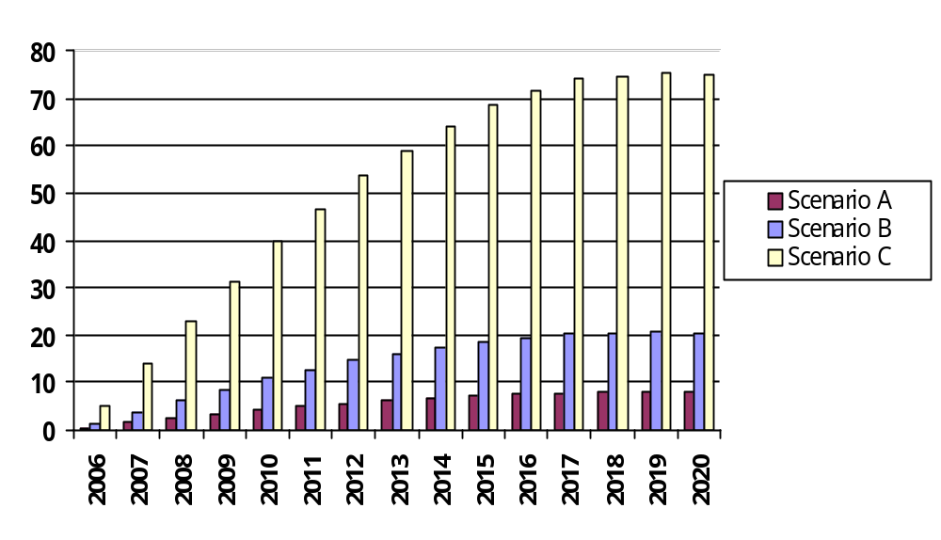
Table 2-4 Annual Increase in Output from Baseline (Mil 96$)
 | 2006 | 2007 |  | 2008 |  | 2009 |  | 2010 |  | 2011 |  | 2012 |  | 2013
Scenario A | 0.523 | 1.484 |  | 2.411 |  | 3.319 |  | 4.181 |  | 4.921 |  | 5.676 |  | 6.218
Scenario B | 1.350 | 3.845 |  | 6.294 |  | 8.636 |  | 10.850 |  | 12.830 |  | 14.730 |  | 16.170
Scenario C | 4.887 | 13.990 |  | 22.930 |  | 31.470 |  | 39.580 |  | 46.770 |  | 53.750 |  | 58.970
 | 2014 |  | 2015 |  | 2016 |  | 2017 |  | 2018 |  | 2019 | 2020 | Total
Scenario A | 6.744 |  | 7.217 |  | 7.523 |  | 7.790 |  | 7.851 |  | 7.912 | 7.874 | 81.644
Scenario B | 17.550 |  | 18.750 |  | 19.610 |  | 20.260 |  | 20.420 |  | 20.640 | 20.460 | 212.395
Scenario C | 64.040 |  | 68.460 |  | 71.560 |  | 73.930 |  | 74.550 |  | 75.360 | 74.720 | 774.967

2-2 Gross State Product
Gross State Product (GSP) as a value added concept is analogous to the national concept of gross domestic product. It is equal to output, excluding intermediate inputs. The value-add concept is equal to compensation and profits. Similar to output, the only negative effect on GSP was the decrease in state government spending due to the loss in state revenues, but is offset by the highly positive effects of consumption, investment, and industrial exports.
For all three scenarios, growth in GSP follows similar trends to output, albeit at a smaller magnitude due to the exclusion of intermediate inputs. The growth rate in all three scenarios is roughly between 26% and 27% during the time frame. Similar to output, the GSP’s initial marginal growth rate is high, but slows down over time.
Scenario A estimates an initial GSP increase of $279 thousand in the first year of the feebates program. GSP grows steadily in the first seven years of the program to $2.953 million in 2012, ten times higher than 2006. By 2020, scenario A estimates a growth of $4.089 million for a cumulative increase of $42.476 million during the time frame.
Scenario B estimates an initial GSP increase of $713 thousand in the first year of the feebates program. GSP grows steadily in the first seven years of the program to $7.668 million in 2012, roughly ten times higher than 2006. By 2020, scenario B estimates a growth of $10.620 million for a cumulative increase of $110.502 million during the time frame.
Scenario C estimates an initial GSP increase of $2.571 million in the first year of the feebates program. GSP grows steadily in the first seven years of the program to $27.970 million in 2012. By 2020, scenario C estimates a growth of $38.760 million for a cumulative increase of $403.200 million during the time frame.
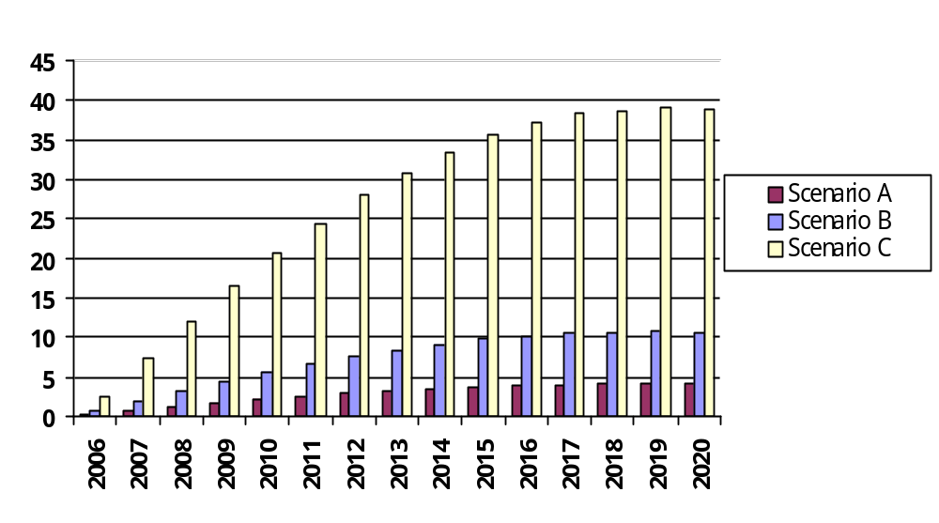

Table 2-5 Annual Increase in GSP from Baseline (Mil 96$)
 | 2006 | 2007 |  | 2008 |  | 2009 |  | 2010 |  | 2011 |  | 2012 |  | 2013
Scenario A | 0.279 | 0.774 |  | 1.274 |  | 1.740 |  | 2.174 |  | 2.571 |  | 2.953 |  | 3.227
Scenario B | 0.713 | 2.010 |  | 3.304 |  | 4.524 |  | 5.688 |  | 6.687 |  | 7.668 |  | 8.404
Scenario C | 2.571 | 7.339 |  | 12.040 |  | 16.510 |  | 20.720 |  | 24.430 |  | 27.970 |  | 30.700
 | 2014 |  | 2015 |  | 2016 |  | 2017 |  | 2018 |  | 2019 | 2020 | Total
Scenario A | 3.517 |  | 3.742 |  | 3.906 |  | 4.047 |  | 4.078 |  | 4.105 | 4.089 | 42.476
Scenario B | 9.136 |  | 9.758 |  | 10.180 |  | 10.510 |  | 10.600 |  | 10.700 | 10.620 | 110.502
Scenario C | 33.330 |  | 35.600 |  | 37.170 |  | 38.340 |  | 38.700 |  | 39.020 | 38.760 | 403.200

2-3 Employment
The Employment variable in REMI Policy Insight uses historical data from the Bureau of Economic Analysis (BEA) and is based upon place of work, including part-time and full-time employees. The employment figures projected below are the difference from baseline and should not be cumulated.
Scenario A estimates an initial employment increase of 4 employees in the first year of the feebates program. Employment grows steadily in the first seven years of the program to 51 in 2012, a little more than ten times higher than 2006. By 2020, scenario A estimates a growth of 72 net new jobs.
Scenario B estimates an initial employment increase of 11 employees in the first year of the feebates program. Employment grows steadily in the first seven years of the program to 133 in 2012, a little more than ten times higher than 2006. By 2020, scenario B estimates a growth of 187 net new jobs.
Scenario C estimates an initial employment increase of 41 employees in the first year of the feebates program. Employment grows steadily in the first seven years of the program to 485 in 2012, more than ten times higher than 2006. By 2020, scenario C estimates a growth of 685 net new jobs.
The decrease in output for the wholesale, petroleum-products-manufacturing, and chemical-manufacturing industry sectors leads to a decrease in employment for those sectors. However, the loss in output for the petroleum-products-manufacturing and chemical-manufacturing sectors is minute enough to prevent a loss in employment in most of the scenarios. There is also a decrease in government employment due to the loss in revenue from gasoline taxes. In 2020, scenario A estimates a loss of 89 state government jobs and 24 jobs in the wholesale industry. Scenario B estimates a loss of 231 state government jobs and 62 jobs in the wholesale industry. Scenario C estimates a loss of 839 state government jobs, 224 jobs in the wholesale industry, and 3 jobs in the petroleum products manufacturing industry. Scenario C has the largest negative impact for state government, wholesale, petroleum-manufacturing, and chemical-manufacturing employment due to the high loss in gasoline output.

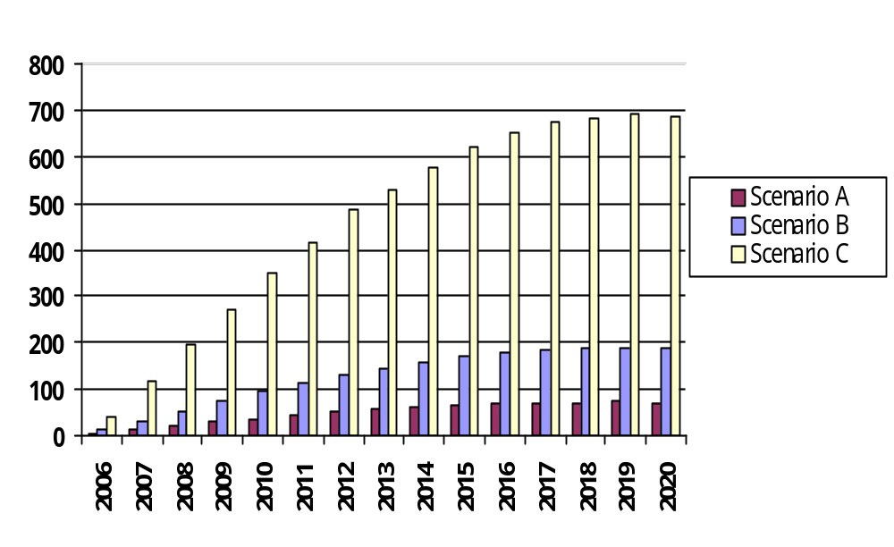Table 2-6 Annual Increase in Employment from Baseline
 | 2006 |  | 2007 |  |  | 2008 |  |  | 2009 |  |  | 2010 |  |  | 2011 |  |  | 2012 |  |  | 2013
Scenario A | 4 |  | 12 |  |  | 21 |  |  | 29 |  |  | 37 |  |  | 44 |  |  | 51 |  |  | 55
Scenario B | 11 |  | 32 |  |  | 54 |  |  | 75 |  |  | 95 |  |  | 114 |  |  | 133 |  |  | 145
Scenario C | 41 |  | 118 |  |  | 196 |  |  | 273 |  |  | 348 |  |  | 417 |  |  | 485 |  |  | 528
 | 2014 | 2015 |  |  | 2016 |  |  | 2017 |  |  | 2018 |  |  | 2019 |  |  | 2020
Scenario A | 61 | 65 |  |  | 68 |  |  | 71 |  |  | 72 |  |  | 73 |  |  | 72
Scenario B | 158 | 170 |  |  | 178 |  |  | 185 |  |  | 187 |  |  | 189 |  |  | 187
Scenario C | 577 | 621 |  |  | 651 |  |  | 674 |  |  | 684 |  |  | 691 |  |  | 685

2-4 Population
Population is a key variable in REMI Policy Insight that affects the potential labor force, government spending, consumption spending, and housing prices. The changes in population are due to changes in migration, the result of either economic growth.
All changes in population are cumulative. Each year shows the difference from the baseline scenario that includes the change in that year plus all preceding years. Due to a lag time in the model, population increases slowly in the initial years of the feebates program. As the economy is further stimulated, the growth rate of economic migration into Rhode Island increases. Scenario A estimates an increase in total population of 189 people by 2020. Scenario B estimates an increase in total population of 488 people by 2020. Scenario C estimates an increase in total population of 1,781 people by 2020.
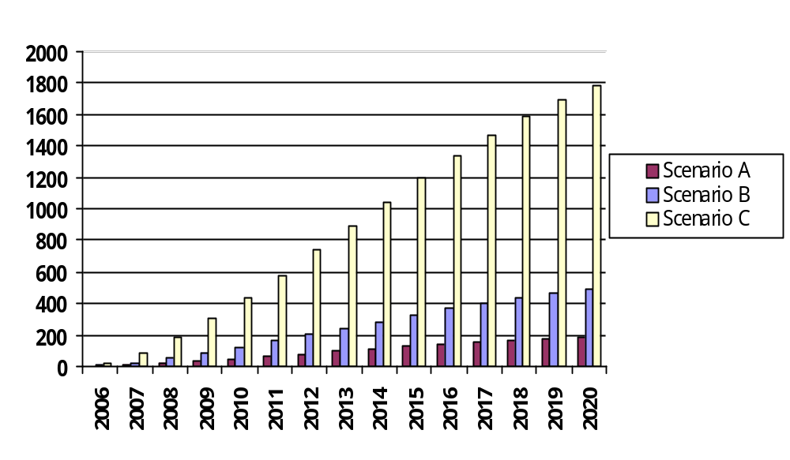Table 2-7 Annual Increase in Population from Baseline
 | 2006 |  | 2007 |  |  | 2008 |  |  | 2009 |  |  | 2010 |  |  | 2011 |  |  | 2012 |  |  | 2013
Scenario A | 3 |  | 9 |  |  | 19 |  |  | 32 |  |  | 46 |  |  | 61 |  |  | 78 |  |  | 94
Scenario B | 7 |  | 24 |  |  | 50 |  |  | 82 |  |  | 119 |  |  | 160 |  |  | 202 |  |  | 244
Scenario C | 24 |  | 87 |  |  | 181 |  |  | 299 |  |  | 434 |  |  | 581 |  |  | 736 |  |  | 891
 | 2014 | 2015 |  |  | 2016 |  |  | 2017 |  |  | 2018 |  |  | 2019 |  |  | 2020
Scenario A | 110 | 126 |  |  | 141 |  |  | 155 |  |  | 168 |  |  | 179 |  |  | 189
Scenario B | 287 | 328 |  |  | 366 |  |  | 402 |  |  | 435 |  |  | 464 |  |  | 488
Scenario C | 1,044 | 1,193 |  |  | 1,335 |  |  | 1,466 |  |  | 1,585 |  |  | 1,691 |  |  | 1,781

2-5 Real Disposable Income
Real disposable income is the inflation-adjusted income that is available for consumers to spend. It equals personal income, minus taxes and social contributions, plus dividends, rents, and transfer payments. The numbers of employees in the area, their wage rate, and the consumer prices all affect real disposable income. An increase in employment or wage, or a decrease in consumers’ prices increases a region’s real disposable income. Consequently, the opposite decreases real disposable income.
The increase in real disposable income is an indirect effect of the new jobs in Rhode Island. The summation of new wages, minus taxes, earned by workers equals the increase in real disposable income. Although there would be a decrease in the amount of spending on gasoline, there would be no direct effect on real disposable income as assumed that any decrease in spending on gasoline would be offset by an increase in spending on other goods (Assumption 2).
Scenario A estimates an initial real disposable income increase of $137 thousand in the first year of the feebates program. By 2020, scenario A estimates a growth of $4.356 million for cumulative increase of $36.325 million during the time frame.
Scenario B estimates an initial real disposable income increase of $370 thousand in the first year of the feebates program. By 2020, scenario B estimates a growth of $11.160 million for a cumulative increase of $93.163 million during the time frame.
Scenario C estimates an initial real disposable income increase of $1.331 million in the first year of the feebates program. By 2020, scenario C estimates a growth of $40.990 million for a cumulative increase of $340.920 million during the time frame.
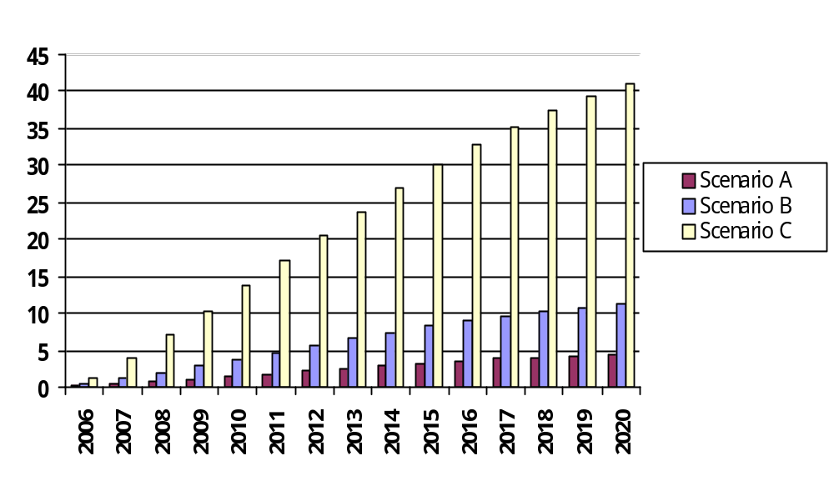

Table 2-8 Annual Increase in Real Disposable Income from Baseline (Mil 96$)
 | 2006 | 2007 |  | 2008 |  | 2009 |  | 2010 |  | 2011 |  | 2012 |  | 2013
Scenario A | 0.137 | 0.427 |  | 0.748 |  | 1.076 |  | 1.446 |  | 1.820 |  | 2.197 |  | 2.537
Scenario B | 0.370 | 1.110 |  | 1.930 |  | 2.815 |  | 3.757 |  | 4.704 |  | 5.646 |  | 6.512
Scenario C | 1.331 | 4.034 |  | 7.065 |  | 10.300 |  | 13.690 |  | 17.130 |  | 20.650 |  | 23.800
 | 2014 |  | 2015 |  | 2016 |  | 2017 |  | 2018 |  | 2019 | 2020 | Total
Scenario A | 2.876 |  | 3.197 |  | 3.506 |  | 3.796 |  | 3.998 |  | 4.208 | 4.356 | 36.325
Scenario B | 7.381 |  | 8.202 |  | 8.961 |  | 9.655 |  | 10.220 |  | 10.740 | 11.160 | 93.163
Scenario C | 26.980 |  | 30.010 |  | 32.760 |  | 35.310 |  | 37.450 |  | 39.420 | 40.990 | 340.920

2-6 State Revenue
State revenue represents the gains or losses in income for the State of Rhode Island from tax revenues. These revenues include individual income tax, general sales tax, tobacco sales tax, property tax, and gasoline tax. All effects are the results of a change in economic activity.
Due to the feebates program there would be a loss in state revenue for the State of Rhode Island. All revenue loss is a direct effect of the demand loss in gasoline. Gasoline is a heavily taxed commodity so any decrease in gasoline consumption decreases the amount of tax collected on gasoline. Also, it is important to note this analysis made the simplifying assumption that the state government would not enact other measures such as increasing the gasoline tax rate to offset the loss in revenue. If the state enacted such measures, it would reduce the loss in state revenue.
Scenario A estimates an initial decrease in state revenues of $513 thousand in the first year of the feebates program. By 2020, scenario A estimates a loss of $7.491 million for cumulative loss of $74.405 million during the time frame.
Scenario B estimates an initial decrease in state revenues of $1.335 million in the first year of the feebates program. By 2020, scenario B estimates a loss of $19.554 million for a cumulative loss of $194.118 million during the time frame.
Scenario C estimates an initial decrease in state revenues of $4.858 million in the first year of the feebates program. By 2020, scenario C estimates a loss of $71.046 million for a cumulative increase of $705.633 million during the time frame.
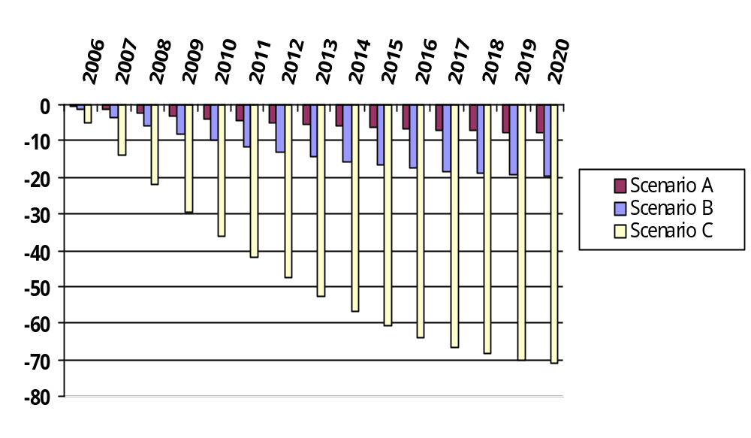

Table 2-9 Annual Decrease in State Revenue from Baseline (Mil 96$)
 | 2006 | 2007 | 2008 | 2009 | 2010 | 2011 | 2012 | 2013
Scenario A | -0.513 | -1.448 | -2.306 | -3.094 | -3.804 | -4.445 | -5.017 | -5.542
Scenario B | -1.335 | -3.774 | -6.013 | -8.059 | -9.912 | -11.593 | -13.082 | -14.458
Scenario C | -4.858 | -13.727 | -21.862 | -29.300 | -36.050 | -42.147 | -47.564 | -52.555
 | 2014 | 2015 | 2016 | 2017 | 2018 | 2019 | 2020 | Total
Scenario A | -6.000 | -6.396 | -6.732 | -7.005 | -7.227 | -7.383 | -7.491 | -74.405
Scenario B | -15.652 | -16.688 | -17.568 | -18.291 | -18.865 | -19.275 | -19.554 | -194.118
Scenario C | -56.910 | -60.655 | -63.860 | -66.491 | -68.564 | -70.044 | -71.046 | -705.633

Appendix: Data Calculations for Inputs into REMI Policy Insight
All data in the Appendix was calculated by Mezler Engineering Services. The following assumptions were made:
- VMT growth rates are considered to be constant across years.
- VMT rebound that will occur due to decreases in the variable cost of driving is not considered.
- Gasoline prices and tax rates are assumed to be constant across years. Current gasoline prices are simply assumed.
- VMT estimates are for all vehicles; so indicated efficiencies are somewhat inaccurate.
- Gasoline sales data are also for all vehicles; so indicated efficiency error is reduced.
- The impacts of regulatory changes in light truck CAFE between 2005 and 2007 are not considered, but these will NOT alter reduction targets.
- The only impact will be to "ease the burden" of the feebate program (i.e., CAFE will provide some of the necessary reductions).
- Calculated fleet turnover rates (and thus interim year scaling factors) assume vehicle sales patterns remain constant.
- To obtain full compliance with goals by 2020, target new vehicle efficiencies based on "full turnover" assumptions will have to be inflated as there is insufficient time to accomplish full turnover by 2020.
- Fraction of models available at a given efficiency is based on data from the 2003 Fuel Economy Guide.
- Efficiency targets are set so that total gasoline consumption (on-road + non-road) complies with design reduction goals.
- It is assumed that the feebate program does not influence vehicle retirement or replacement and that high efficiency vehicles have the same lifespan as low efficiency vehicles.

In examining the economic impact for each geographic region, three different feebate designs were modeled. Each scenario corresponds to levels in a loss of demand for gasoline consumption due to the increase in fuel efficiency. Scenario A assumes that the feebate policy will reduce 2020 gasoline consumption by the difference in consumption between 1990 and 2003. Scenario B assumes that the feebate policy will reduce 2020 gasoline consumption by the difference in consumption between 90% of 1990 and 2003. Scenario C assumes that the feebate policy will reduce 2020 gasoline consumption to 90% of 1990 consumption. Table A-1 displays the baseline gasoline consumption rates and the target consumption rates of the three feebate scenarios for the State of Rhode Island.

Table A-1 Baseline and Scenario Target Gasoline Consumption Rates (1,000 Gal)
 | 1990 Baseline | 2003 Baseline | 2020 Baseline | 90% of 1990 Target | Scenario A | Scenario B | Scenario C
Gas Consumption | 377,590 | 401,102 | 498,907 | 339,831 | 475,395 | 437,636 | 339,831
Table A-2 Target Feebate Program Rates, 2020
 | Scenario A | Scenario B | Scenario C
Change in Fleet Fuel Consumption | -5% | -12% | -32%
Increase in Fleet Fuel Economy | 5% | 14% | 47%
Fleet Fuel Economy (mpg) | 21.09 | 22.91 | 29.51
Consumer Savings (Bil $) | 0.047 | 0.123 | 0.318
State Tax Loss (Mil $) | 7.29 | 18.99 | 49.31
Retailer Loss (Bil $) | 0.04 | 0.09 | 0.24

About REMI
Regional Economic Models, Inc. (REMI) is the nation’s leading provider of economic forecasting and policy analysis software. The REMI Policy Insight model is used by over half of state governments, and numerous consulting firms, cities, and universities. Established in 1980, REMI has published model developments in the American Economic Review, the Review of Economics and Statistics, and other highly regarded publications.
Contact: Frederick Treyz, Ph.D., CEO, REMI
(413) 549-1169
fred@remi.com

Jefferson Clarke, Economic Consultant, REMI
(413) 549-1169
jefferson@remi.com

Billy Leung, Economic Consultant, REMI
(413) 549-1169
billy@remi.com

For the individual state runs, each state was run as a single economy. There was no consideration of the impacts from other states.
Gasoline consumption estimates were provided by Mezler Engineering Services

